Select the Plus and click.

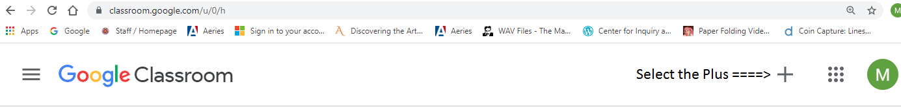

Click Join Class

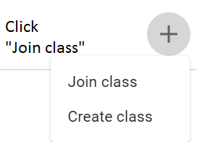

Enter the class code

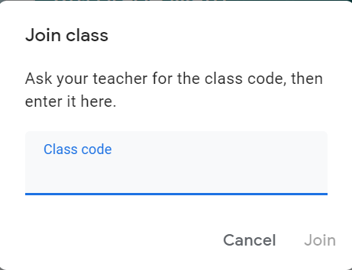

🡸 Press Join after you enter the class code.

🡸class code goes in this field.